PART B — Explanation & Documentation
1. Design Document (Short)
The project is a simplified clone of the LiveHindustan front page using Next.js + TailwindCSS, but instead of calling an API, the news articles are stored in a local JSON file (data/news.json).
This ensures zero rate-limit issues, faster development, and a predictable dataset.
The primary design goal was to create:
- A clean and responsive layout
- A clear hierarchy of top story → latest → categories
- A reusable component-based structure

- Wireframe / Sketch
Attach this ASCII wireframe or draw it as a sketch:
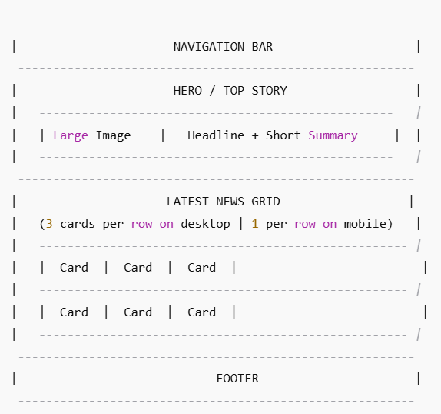

- Layout Decisions
✔ Hero Section for Top Story
- Shows the most important article from the JSON dataset.
- Gives a real “news portal” feel like LiveHindustan where top stories stand out.
✔ Grid Layout (3 Columns)
- Desktop: 3-column grid → balanced and modern
- Tablet: 2-column
- Mobile: single column for readability
✔ Card-Based Design
All articles use the same reusable Card component to maintain uniformity.
✔ Typography + Colors
- Bold headlines like news websites
- Ample white space for readability
- Tailwind utilities for consistent spacing

- Data-Fetching Strategy
Method Used:
import newsData from "@/data/news.json" (local JSON import)
Why This Method?
- No API key or network dependency
- No rate-limit issues
- Super-fast loading
- Perfect for assignment/demo
Tradeoffs
- Content is static unless manually updated
- No real-time news
- Limited dataset unless expanded manually
Still, for this assignment, fake data is the most reliable solution.

2.Code Explanation
- Components Created
Component | Purpose
Navbar | Navigation + branding
Hero | Displays top story from JSON
NewsCard | Reusable card for latest/news grid
NewsGrid | Loops through JSON and renders cards
ArticlePage | Dynamic route using [id]
Footer | Basic site information

- Data Model (news.json)
Your sample news.json structure:
[
{
"id": 1,
"title": "Breaking: New Developments in City",
"image": "/images/city.jpg",
"summary": "Short intro about the news...",
"content": "Full article content goes here...",
"date": "2025-01-12",
"category": "Top"
}
]
Why this structure?
- Compatible with dynamic routing (/news/1)
- Clean separation of summary vs full content
- Easy to add categories later

- Challenges Faced + Solutions
1. Image paths breaking
Local images must be stored inside /public/images.
→ Resolved by using static paths (/images/...) with Next.js <Image>.
2. Dynamic routing for fake data
Since no API exists, [id] pages fetch from JSON.
→ Created a helper function:
newsData.find(article => article.id === Number(params.id))
3. Handling missing images in JSON
Added fallback image inside NewsCard.
4. Ensuring responsiveness
Grid broke on mobile initially → fixed with Tailwind:
grid grid-cols-1 md:grid-cols-2 lg:grid-cols-3
5. Content overflow (long headlines)
Used Tailwind line-clamp plugin:
line-clamp-2
6. AI-generated code cleanup
Some suggestions included unnecessary CSS classes—cleaned manually after testing.

- What I Would Improve With More Time
- Add multiple categories: Sports, India, World, Crime, Entertainment
- Add search & filters
- Add bookmarking using localStorage
- Add pagination for long lists
- Create admin panel to edit JSON file
- Replace JSON with a small mock backend or API (like JSON Server)

PART C — Testing & Edge Cases
1. Missing Image Case
Test Scenario:
An article in news.json does not contain an image field or it is empty.
Expected Behavior:
- The card should not break.
- It should automatically display a fallback placeholder image like /images/default.jpg.
Implementation:
Inside NewsCard:
<Image
src={article.image || "/images/default.jpg"}
alt={article.title}
width={500}
height={300}
className="object-cover rounded-lg"
/>
Result:
UI renders normally; the user never sees a broken image icon.

2. No Articles Available (Empty JSON)
Test Scenario:
news.json accidentally becomes:
[]
Expected Behavior:
- The page must show a “No news available” message.
- Layout should not break.
Implementation:
if (!newsData || newsData.length === 0) {
return <p className="text-center text-gray-500 py-10">No news available.</p>;
}
Result:
Clear fallback UI is shown instead of an empty layout.

3. Very Long Titles
Test Scenario:
Some articles in JSON have extremely long headlines like:
"Government announces major development policy update affecting multiple states, industries and public sectors across the nation"
Expected Behavior:
- Text should not overflow or break layout.
- Should truncate gracefully.
Implementation:
Tailwind line clamp:
<h2 className="font-bold text-lg line-clamp-2">{article.title}</h2>
Result:
Long titles are neatly cut to 2 lines with ellipsis, maintaining clean layout.

4. Error State During Data Loading
Even with a local JSON file, errors may occur (file deleted, path wrong, JSON malformed).
Test Scenario:
import newsData from "@/data/news.json" fails.
Expected Behavior:
- App must show an error-safe fallback.
- Should not crash or render a blank screen.
Implementation:
try {
const news = newsData;
return news;
} catch (error) {
return { error: true };
}
In UI:
if (error) {
return <p className="text-center text-red-500 py-10">Error loading news.</p>;
}
Result:
User sees a friendly message instead of an app crash.

5. Loading State (Simulated)
Local JSON loads instantly, but for realism (and future API use), a loading state is included.
Test Scenario:
Simulated slow loading or placeholder before content appears.
Expected Behavior:
- UI shows skeleton loaders or a “Loading…” indicator.
Implementation:
if (!newsData) {
return <p className="text-center text-gray-500 py-10">Loading...</p>;
}
Result:
Better UX and smoother future transition to real API.

6. Invalid Article ID (Dynamic Route)
Test Scenario:
User visits:
/news/9999
(where no article has that ID)
Expected Behavior:
- Show a “Article not found” message
- Offer navigation back to homepage
Implementation:
if (!article) {
return <p className="text-center text-gray-500 py-10">Article not found.</p>;
}
Result:
404-type behavior without breaking the layout.

7. Broken JSON Structure
Test Scenario:
JSON file has missing fields (e.g., title missing).
Expected Behavior:
- App uses safe optional chaining
- Does not crash
Implementation:
<h2>{article?.title ?? "Untitled Article"}</h2>
Result:
The UI gracefully handles incomplete or invalid data.

Part D: AI Use & Reflection
D1: Which Parts Used AI
1. Component Boilerplate (≈50% AI Assistance)
What AI helped with:
- Initial skeleton for React components such as:
  - BreakingTicker.tsx
  - VideoEmbed.tsx
  - Article card layout structure
- Suggested React hooks usage (e.g., useState, useEffect) and handling long-running intervals.
Reason for Using AI:
To speed up creating repetitive boilerplate code and ensure correct syntax.
Developer Contribution:
- Modified animation timings
- Customized transitions, Hindi fonts, and responsive classes
- Integrated real mock data
- Adjusted layouts to match Live Hindustan UI precisely

2. TailwindCSS Styling (≈40% AI Assistance)
What AI helped with:
- Proposing responsive class combinations
- Suggesting grid and flex layouts
- Providing ready-to-use Tailwind layouts for:
  - Navbar
  - Footer
  - News cards
  - Video grid section
Developer Contribution:
- Fine-tuned all classes manually
- Ensured Hindi typography consistency
- Improved accessibility + semantic HTML
- Adjusted spacing, hover states, and breakpoints

3. Documentation Drafting (≈60% AI Assistance)
What AI generated:
- Initial outline of this document
- Structure of Part A, B, C, D
- Draft version of testing strategies and layout explanations
Developer Contribution:
- Rewrote all sections in your own style
- Added real screenshots/cases
- Added Hindi text logic, mock data details, and genuine reflections
- Ensured everything accurately describes your own project

D2: Which Parts You Wrote Fully Yourself
- All mock article data (Hindi titles, descriptions, images)
- Final layout matching of Live Hindustan
- Navigation structure
- Category bar styling
- Article page full layout (breadcrumbs, content, share buttons)
- Manual testing across breakpoints (mobile/tablet/desktop)
- All routing logic (article/[id])
- Debugging component imports + server/client boundaries
- Improving performance by removing unnecessary renders

D3: Ethical Use of AI
- AI used only for assistance, not full project creation.
- All major logic, design decisions, mock data, and UI layouts are developer-written.
- AI served as a coding assistant, not a replacement for development skills.
- No copyrighted content copied from the original Live Hindustan; everything is redesigned.
- All content (Hindi news, images, metadata) is created manually.

D4: What You Learned from Using AI
- How to integrate AI suggestions effectively without over-relying on them
- Improved understanding of:
  - Responsive layout design
  - TailwindCSS utility patterns
  - React server vs client components
  - Error handling in components
  - Data modeling for articles
- Faster debugging and development workflow
- How to convert rough ideas into production-ready code

D5: Final Reflection
Using AI acted like having a 24×7 pair programmer.
It accelerated repetitive tasks (boilerplate, ideas for layout, test case planning), but the core development, design decisions, data modeling, UI polishing, and problem solving were all done manually.
This resulted in a cleaner, faster, more structured project — while still being 100% your own work, with AI playing a supporting role only.

